Introduction To Devops

Assignment

Name : Gorla Manoj Kumar

Bits ID : 2016HW86252

**Assignment 2**

• **Title of the assignment**

-> Deployment of jenkins LTS solution for achieving Continuous Build for a Software.

**Problem statement:**

-> Perform a jenkins LTS Deployment and install the plugin of Git and Maven. After Successful deployment change the access port for Jenkins from 8080(default) to 9090. Also list the need and benefits of jenkins.

**Definition of Jenkins:** Jenkins is an open source continuous integration/continuous delivery and deployment (CI/CD) automation software DevOps tool written in the Java programming language. It is used to implement CI/CD workflows, called pipelines.

As we can see default the port value is 8080

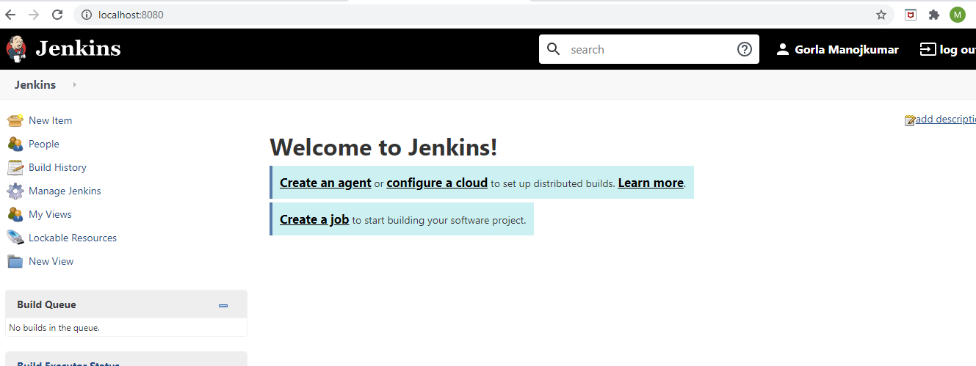

Since Admin previliges is required for changing port value, So we have installed Jenkins manually with the plugin of Git and Maven.

We can change the port value by performing the below.

Open command prompt in admin mode

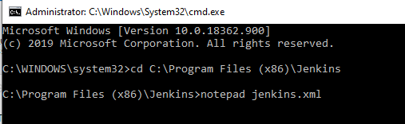

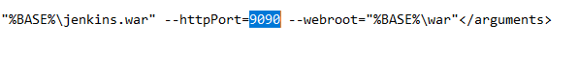

Then we have to Restart the services

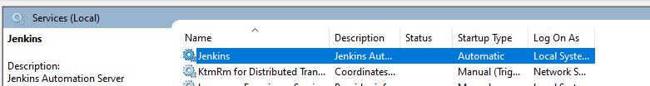

After changing the Port value from 8080 to 9090 we will get Login page

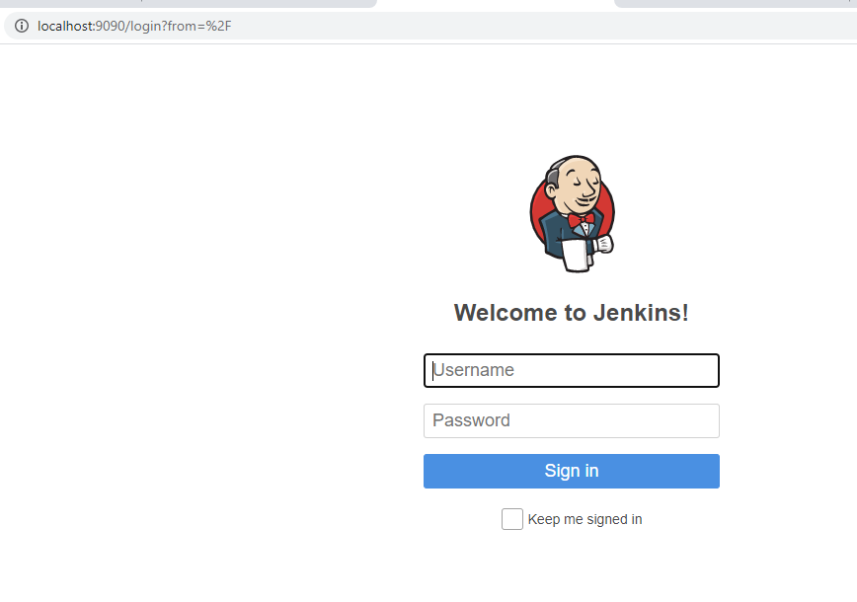

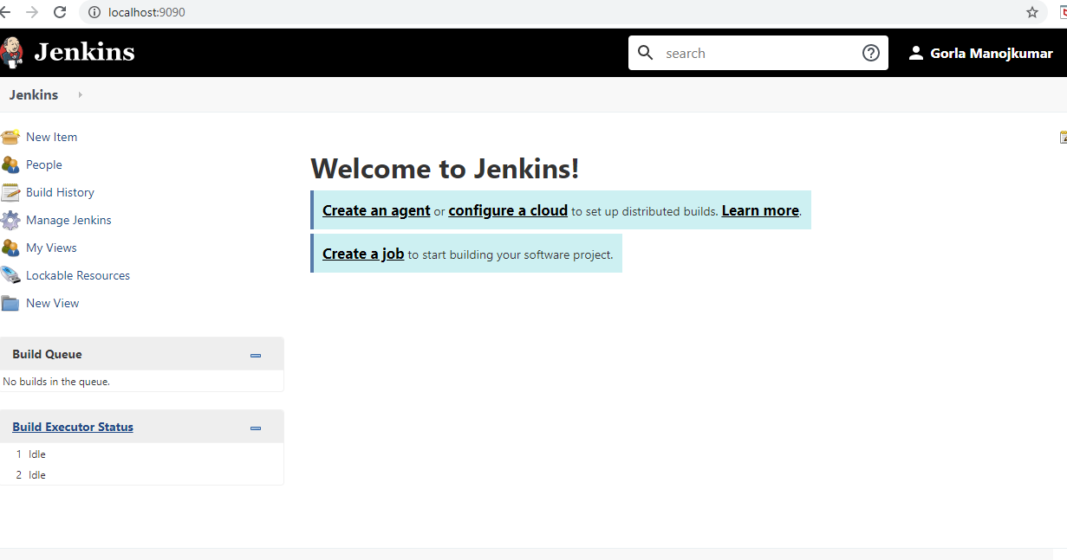

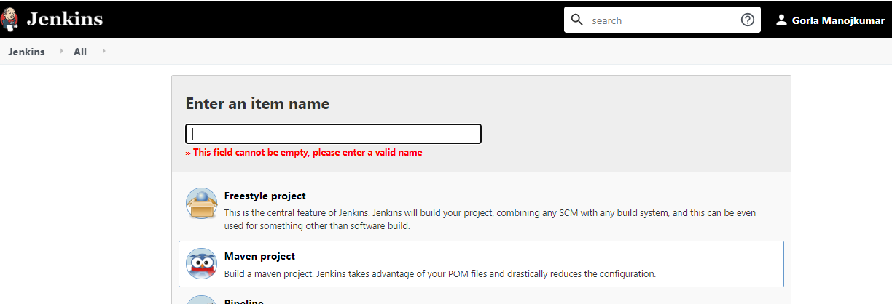

Before we accessing the file from maven, first we will create file in Git

To create repository using git

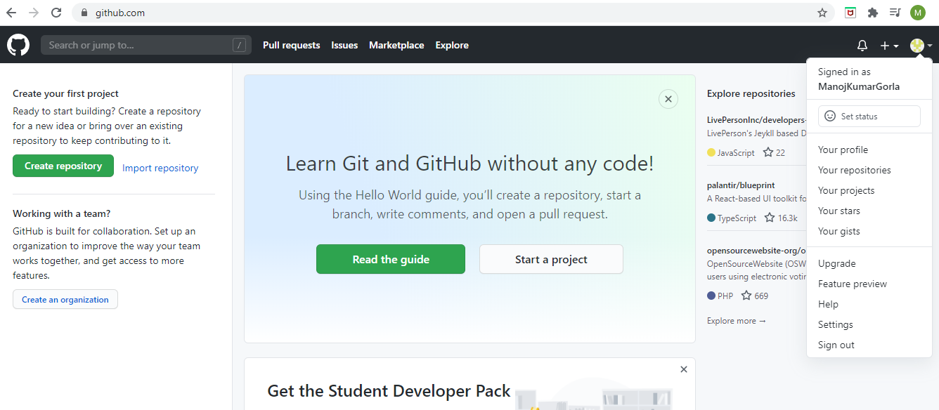

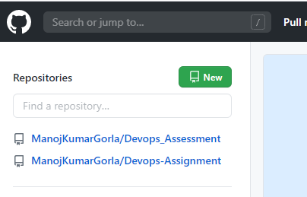

By clicking on New we can create Repo

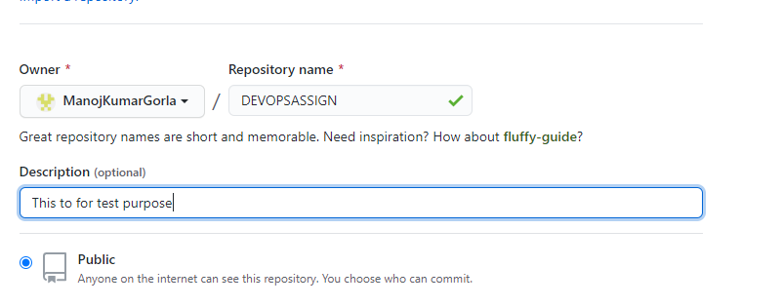

Description will explain the details of the project

Have to select Initialize this repository with a README

Then we can select Create Repo

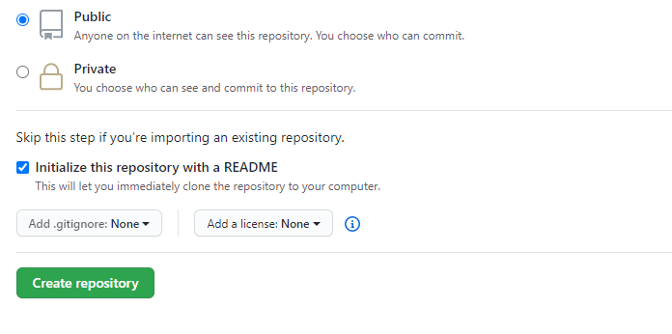

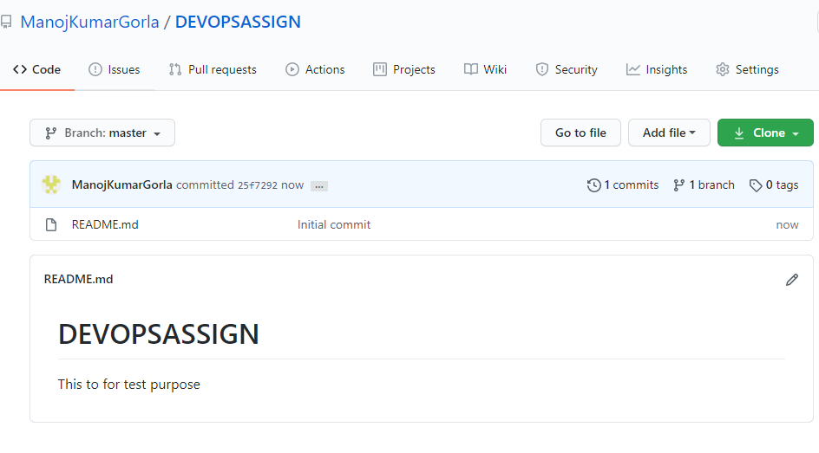

By clicking on edit we can make the modification of our code

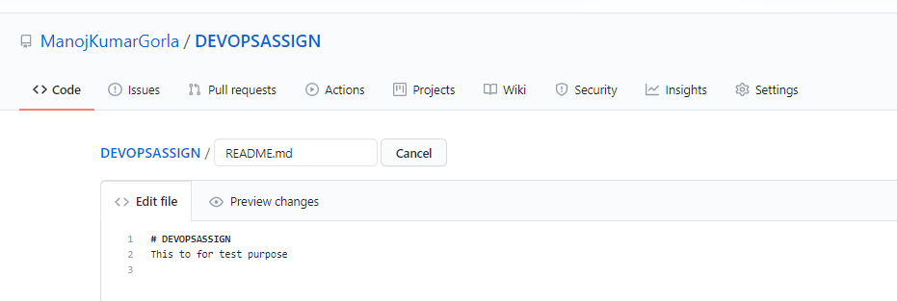

Once modification done have to select commit then changes will be saved

